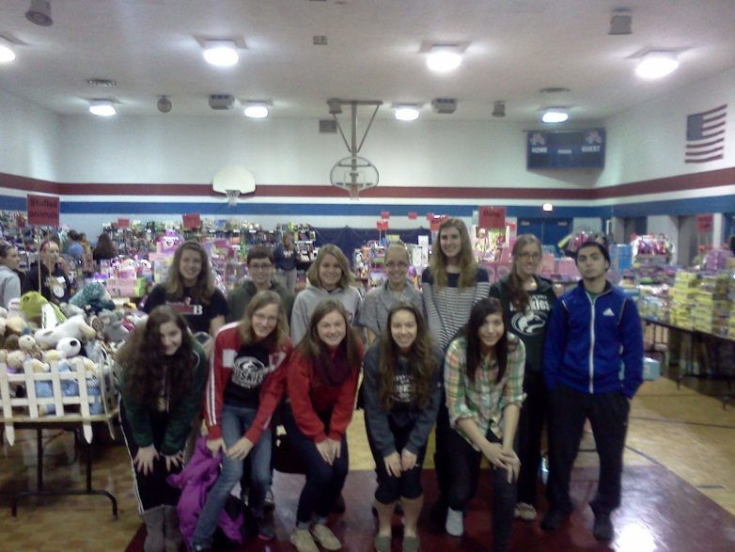
Community Service Opportunity! Christmas Clearing Council of Waukesha County invites the community to help it accomplish its mission of making Christmas brighter for thousands of area children by dropping off new, unwrapped toys between November 1 and December 10. Our Spanish National Honor Society would like to assist. If you want to participate, please bring an unwrapped, new toy, book, stuffed animal, or sporting equipment to Room 272 to be donated to this organization.
Also, we need your time. The Annual Toy Shop held on Dec. 13 for children in need. Last year, our Spanish National Honor Society was presented with the “2013 Youth Group Angel Award” for our continued service as Spanish Interpreters for this event. This event will require you to show up at St. William’s Church in WAUKESHA by 7:30am on a SATURDAY morning. You will be expected to serve until NOON. At that point you can get lunch or leave. You will earn 5 hours of service. You can stay until 2pm and earn 7 hours of service. If you are interested in getting some community service (in Spanish) please sign up with ProfeGH / Bridget Geboy-Helfenstein in Room 272.
All students who study Spanish in levels 3-7 are welcome to join us. Any NATIVE SPANISH SPEAKERS who are not in Spanish Classes and who wish to help your community PLEASE JOIN US. You do not have to speak Spanish fluently to participate. You can assist a Spanish speaking student by carrying a bin filled with toys!
Sociedad Honoraria Hispanica
Capítulo Volcán Arenal
Nathan Hale Spanish National Honor Society

